**Report on Fake Name Generator**

**Cyber Intel**

# Executive Summary

Fake Name Generator is a web-based tool to generate fake identity with country, name set, ethnicity, age and gender as input for the identity. The identity generated consists fields like personal information, including names, addresses, phone numbers, email addresses, usernames, passwords, address, card numbers, employment details, physical characteristics and many more. It also offers to generate bulk identities. The website also provides multiple validator tools like credit card validator, Canadian social insurance number validator, UK national insurance number validator, US social security number, vehicle identification number validator etc.

# Index

**Executive Summary 2**

**Index 2**

**1. Introduction 2**

**2. Tool Details 2**

**3. Installation 3**

**4. Execution 3**

**5. Scope and Limitations 3**

**6. Conclusion 3**

**7. References (if any) 4**

# Introduction

Fake Name Generator is a web-based tool that generates random fake identities. It provides users with a variety of personal information, including names, addresses, phone numbers, email addresses, usernames, passwords, and more. This tool can be useful for various purposes such as creating fictional characters for writing or gaming, protecting privacy during online activities or testing software applications. The generated information appears realistic and includes details like age, gender, nationality, occupation, blood type and zodiac sign.

Additionally, the website offers options to generate identity sets from different countries and even specific states within those countries. Overall, the Fake Name Generator is a convenient tool for generating plausible but fictitious identities when needed.

There are other set of tools available at the same domain –

* **FNG's Credit Card Validator** - <https://www.fakenamegenerator.com/credit-card-validator.php>
* **FNG's ABA/Routing Number Validator -** <https://www.fakenamegenerator.com/aba-validator.php>
* **FNG's CA Social Insurance Number (SIN) Generator & Validator –** Canadian social insurance number generator and validator – <https://www.fakenamegenerator.com/social-insurance-number.php>
* **FNG's UK National Insurance Number (NINO) Generator & Validator** - UK national insurance number generator and validator – <https://www.fakenamegenerator.com/national-insurance-number.php>
* **FNG's US Social Security Number (SSN) Generator & Validator** – US social security number generator and validator - <https://www.fakenamegenerator.com/social-security-number.php>
* **Name Generator.in** - Pick a state and instantly generate a business card, complete with company name and title - <https://namegenerator.in/>
* **The Sims Family Generator** - Quickly and easily generate names for your entire Sims family - <https://www.fakenamegenerator.com/the-sims.php>
* **Vehicle Identification Number** - Validate the check digit in a vehicle identification number - <https://www.fakenamegenerator.com/vehicle-identification-number.php>
* **PIC/CIC Code Database -** PIC/CIC codes allow you to have your long-distance calls handled by the carrier of your choice. Look up all the PIC and CIC codes at the Allred Tech CIC database site - <https://www.allredtech.com/>

# Tool Details

Tool available at - <https://www.fakenamegenerator.com/>

Accessed –

* using Microsoft Edge
* on 23 September 2023
* no VPN required

Use case list –

* Protecting privacy while signing up for websites or online services that require personal information.
* Testing software applications that involve user registration and data input.
* Generating sample data for database testing or populating test environments.
* Simulating realistic user profiles in user interface design and development.
* Enhancing security by using fake identities to confuse potential attackers or spammers.
* Safeguarding personal information when participating in online surveys, contests, or promotions where real details are not necessary or desired.

# Installation

No installation required; Fake Name Generator Tool can be directly accessed using a browser by visiting link – <https://www.fakenamegenerator.com/>

# Execution

* + - 1. Generating Random Identity –
* Gender – Male
* Name Set – Chinese
* Country – United States

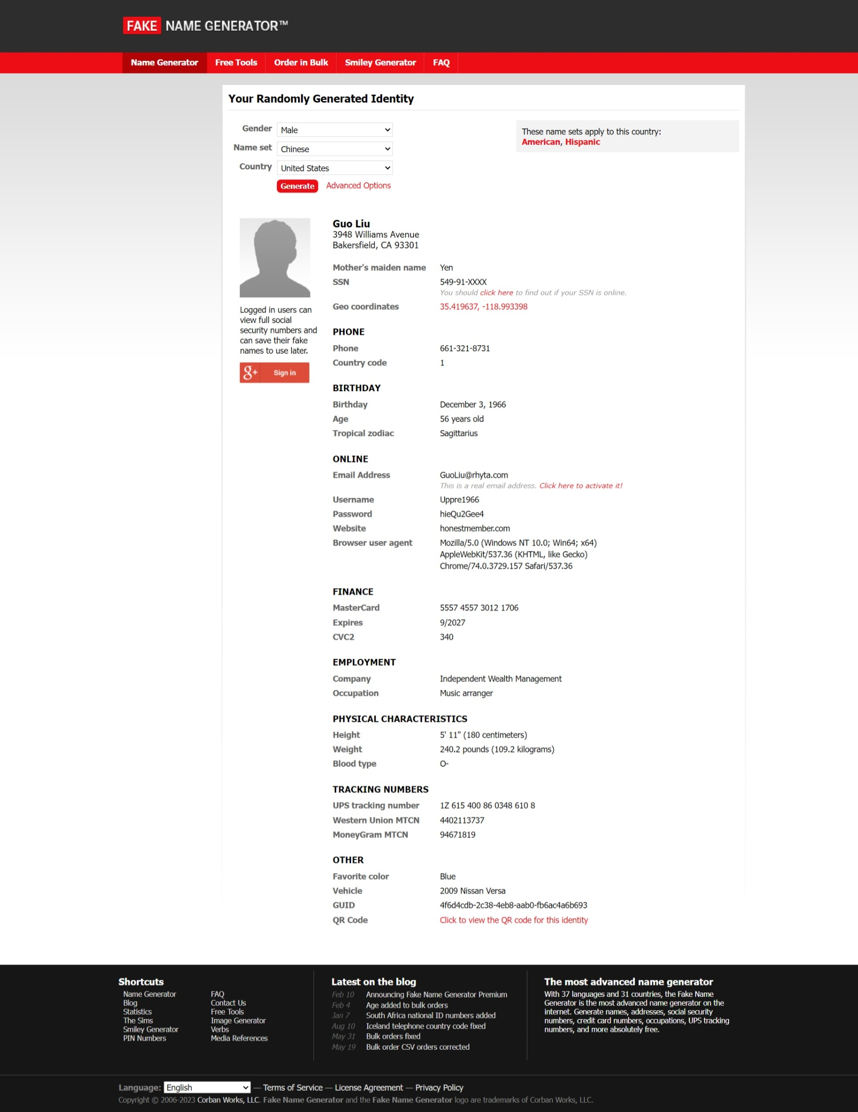

* + - 1. Generating Bulk fake identity and exporting into .csv file as zip.

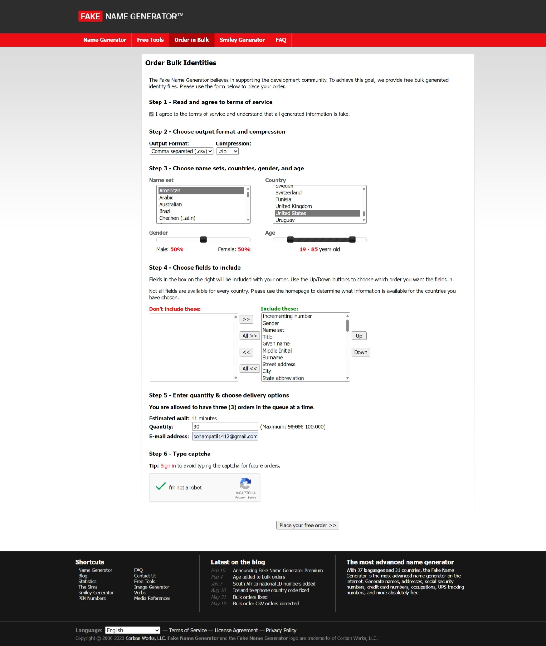

Generated identities –

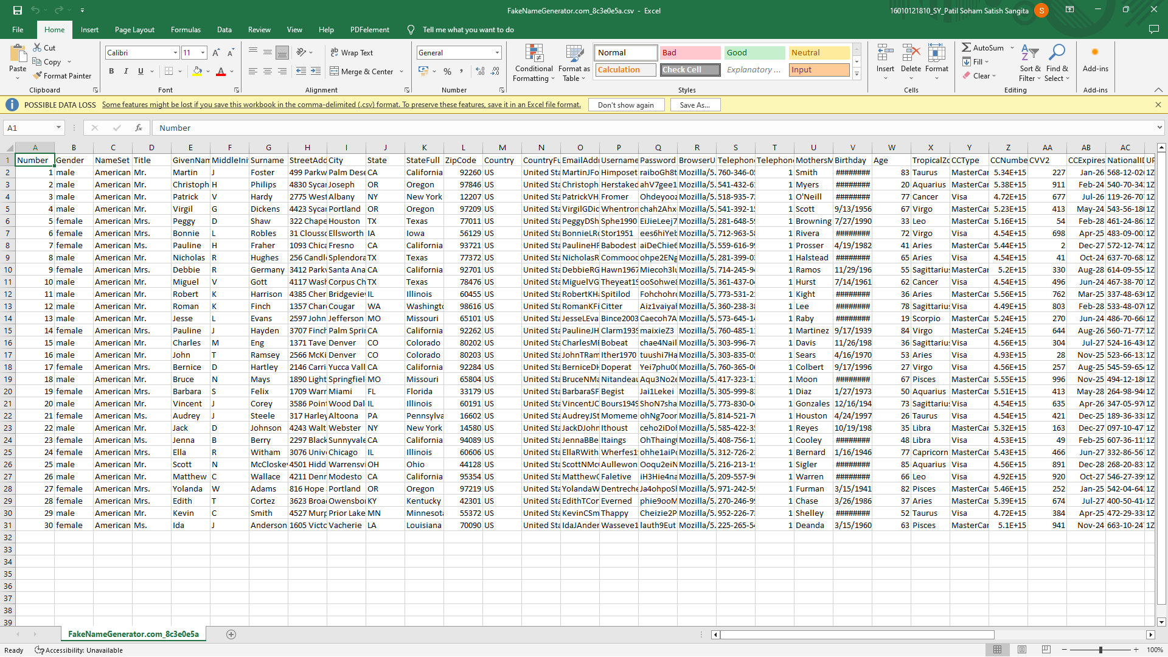

Other tools provided –

* Credit Card Validator

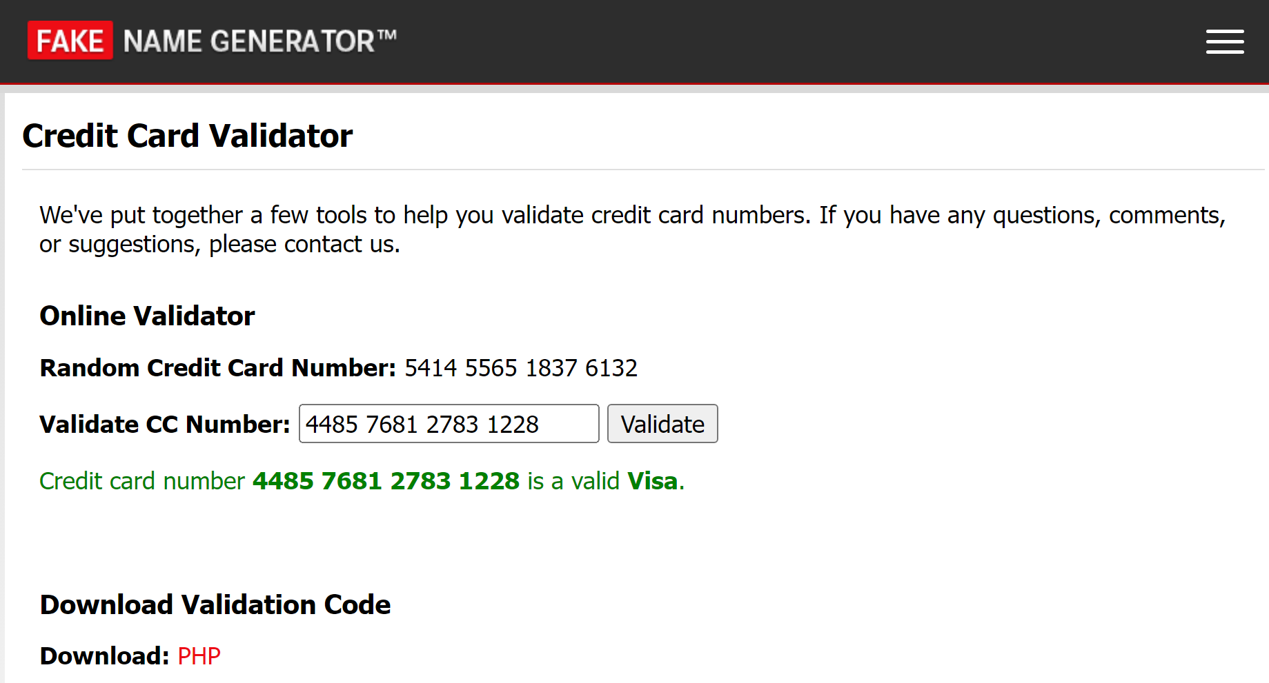

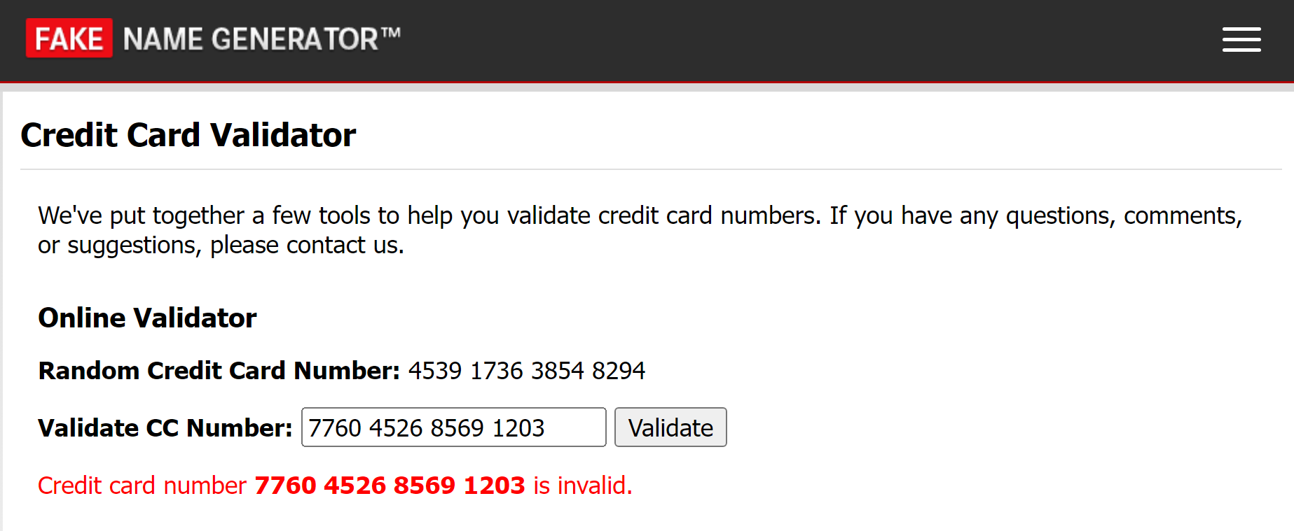

* Canadian Social Insurance Number (SIN) Validator

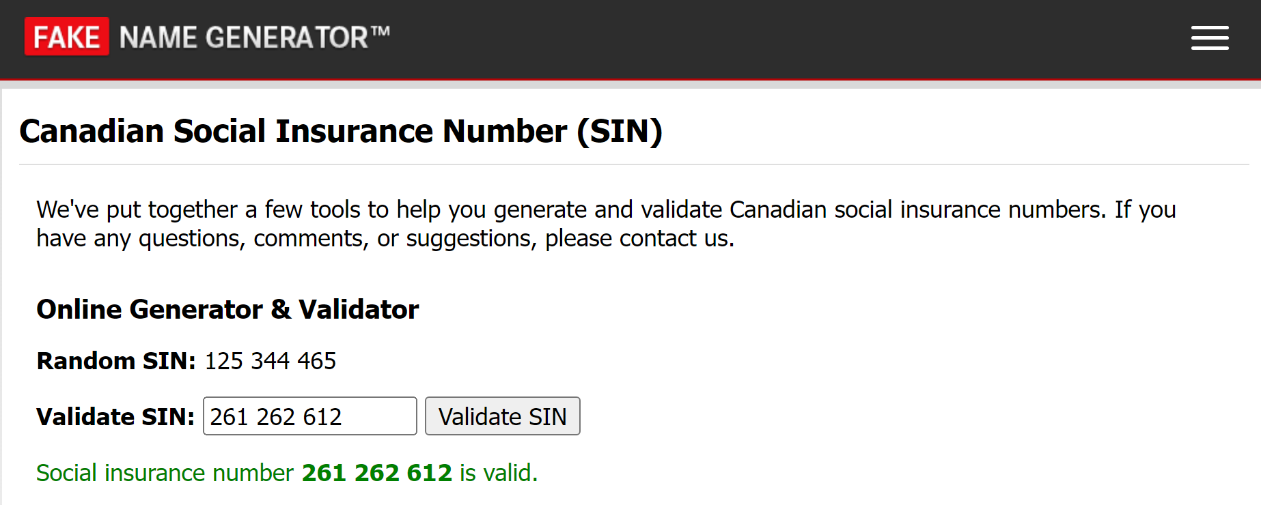

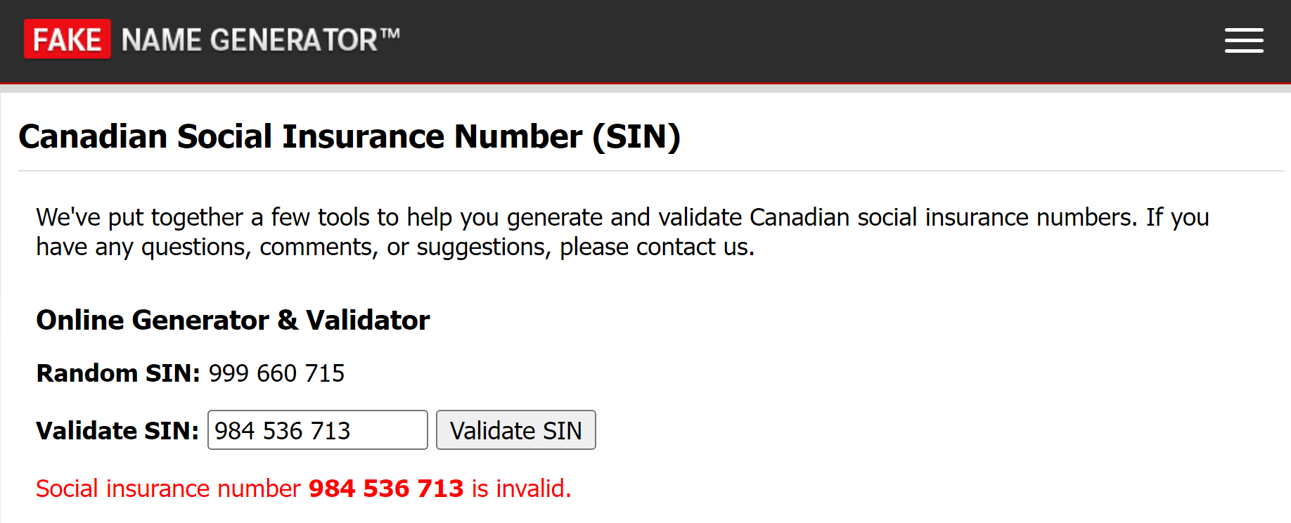

* UK National Insurance Number (NINO) Format Validator

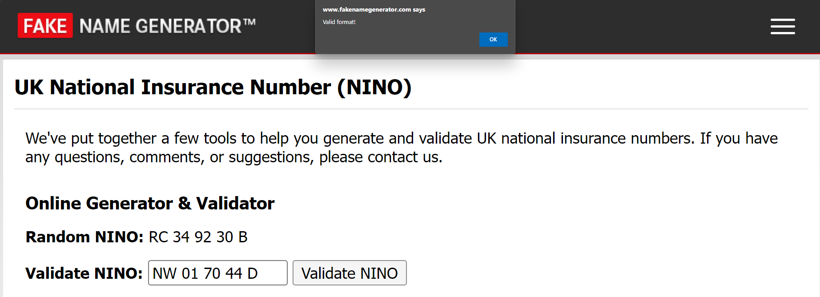

* US Social Security Number (SSN) Validator

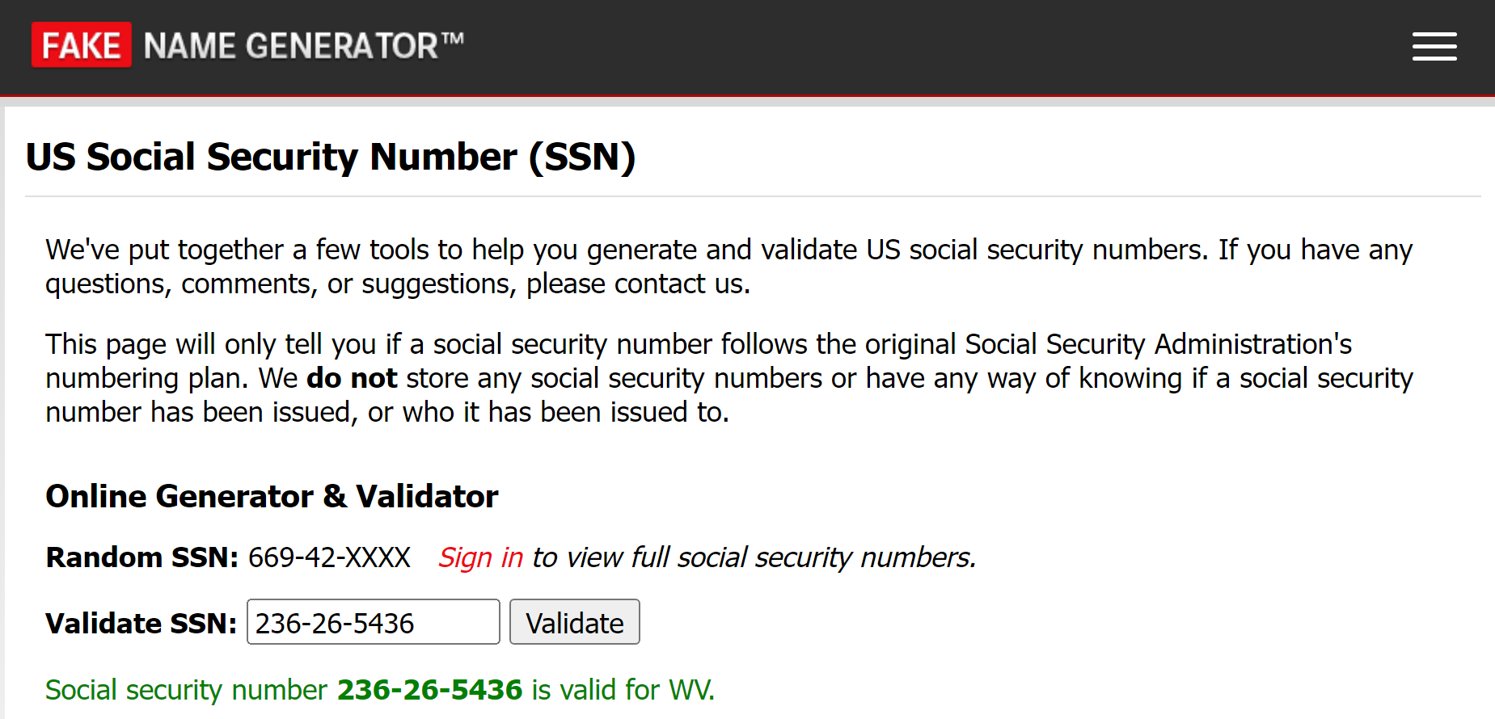

* Vehicle Identification Number Validator

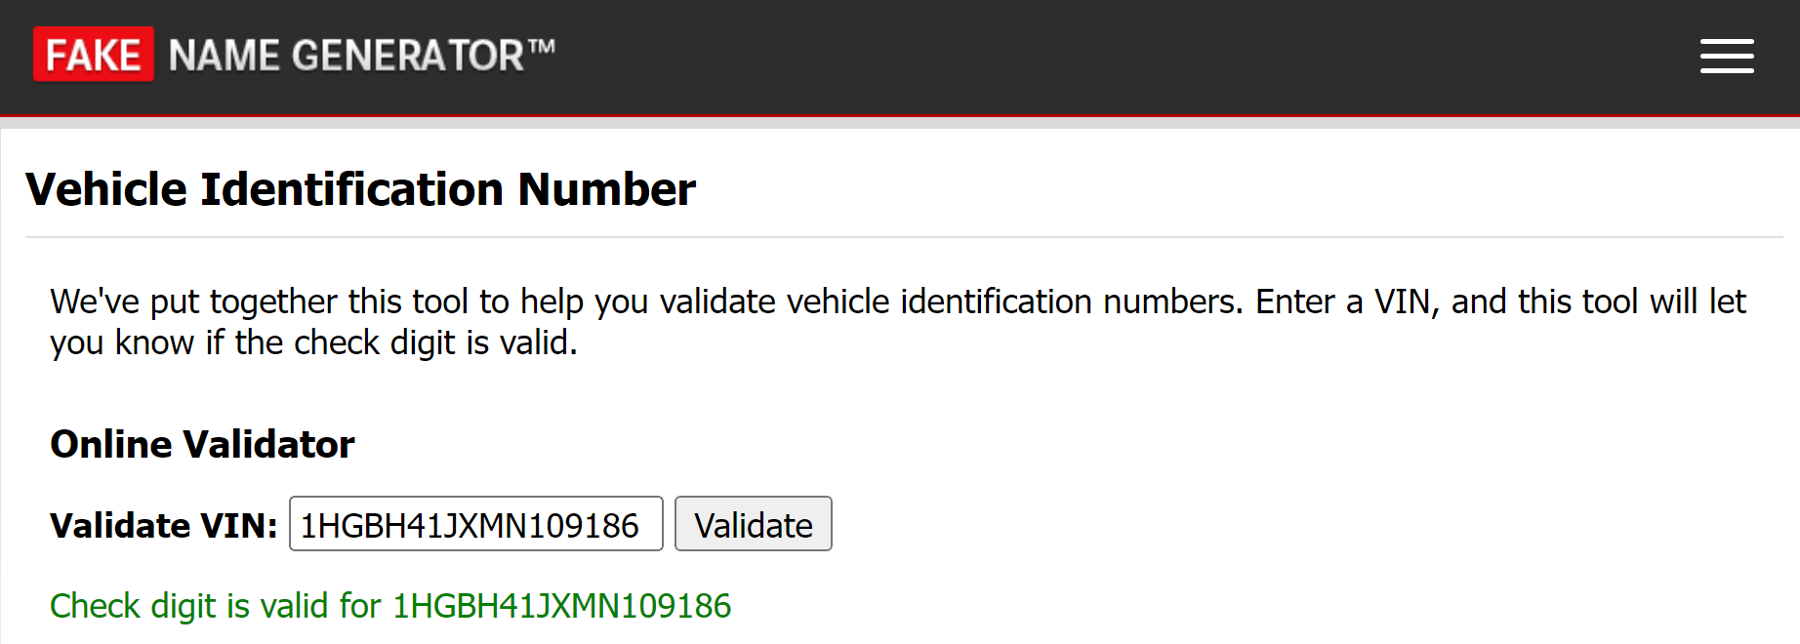

# Scope and Limitations

The tool generates realistic fake identities, including names, addresses, phone numbers, email addresses, usernames, passwords, and more. It offers options to generate identity sets from different countries and specific states within those countries. The generated information appears authentic and can be used in various scenarios such as writing, gaming, testing applications or protecting privacy.

The generated identities are completely fictitious. They should not be used for any illegal activities or misrepresentation. While the information may seem legitimate at first glance, it is important to note that it is entirely made up and does not correspond to real individuals. Some websites or services may have robust verification processes that can detect fake identities. Therefore, this tool might not work effectively in all cases. The generated data lacks real-life history or background details associated with genuine individuals. Thus, it cannot replicate complex personal histories accurately. It's essential to exercise caution while using these fake identities since they do not provide actual protection against determined adversaries or advanced tracking techniques.

The website also provides other add-on tools like credit card validator, Canadian social insurance number validator, UK national insurance number validator, US social security number, vehicle identification number validator. These tools can be used as validator for various identification numbers. A major drawback of these tools is the they just check the format of the number to validate it, they don’t have a database to check if the number really exists.

# Conclusion

In conclusion, the Fake Name Generator tool is a valuable resource for generating random fake identities. With its wide range of personal information options and customization features, this tool serves various purposes, from creating fictional characters to protecting privacy online. The generated identities appear realistic and include details that add credibility to any project or situation where a fictitious identity is required. Whether you are a writer looking for character inspiration, an individual seeking anonymity in online activities, or a software developer testing user data scenarios, this tool provides reliable and convenient solutions. The Fake Name Generator proves to be an efficient and reliable tool that simplifies the process of generating plausible but unreal identities with ease.

# References

* <https://www.fakenamegenerator.com/>
* <https://www.fakenamegenerator.com/order.php>
* <https://www.fakenamegenerator.com/free-tools.php>
* <https://www.fakenamegenerator.com/credit-card-validator.php>
* <https://www.fakenamegenerator.com/social-insurance-number.php>
* <https://www.fakenamegenerator.com/national-insurance-number.php>
* <https://www.fakenamegenerator.com/social-security-number.php>
* <https://www.fakenamegenerator.com/vehicle-identification-number.php>